Puzzle - Light Sensor 光敏传感器

产品简介
光敏传感器，也叫做光敏电阻，当环境光强增大时，电阻减小。
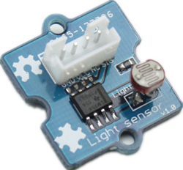
规格参数
- 工作电压：3-5V
- 工作电流：0.5-3mA
- 光电阻：20KΩ
- 暗电阻：1MΩ
- 响应时间：20-30S
- 波长阈值：540nm
- 工作温度：-30~70 ℃

应用示例
接下来这个示例将演示如何用光控制LED——当环境光变弱时，LED就被点亮了。将Puzzle - Light Sensor接至模拟口A0，Puzzle - LED接至数字口12。

/*
/* Puzzle- Light Sensor demo v1.0
* signal wire to A0.
*/
#include <math.h>
const int ledPin=12; //Connect the LED Puzzle module to Pin12, Digital 12
const int thresholdvalue=10; //The treshold for which the LED should turn on.
// Setting it lower will make it go on at more light, higher for more darkness
float Rsensor; //Resistance of sensor in K
void setup() {
Serial.begin(9600); //Start the Serial connection
pinMode(ledPin,OUTPUT); //Set the LED on Digital 12 as an OUTPUT
}
void loop() {
int sensorValue = analogRead(0);
Rsensor=(float)(1023-sensorValue)*10/sensorValue;
if(Rsensor>thresholdvalue)
{
digitalWrite(ledPin,HIGH);
}
else
{
digitalWrite(ledPin,LOW);
}
Serial.println("the analog read data is ");
Serial.println(sensorValue);
Serial.println("the sensor resistance is ");
Serial.println(Rsensor,DEC);//show the ligth intensity on the serial monitor;
delay(1000);

}

参考资料
- Puzzle - Light Sensor 电路图文件
- LM358 数据表
- Light Sensor 库文件
- 点击购买

